DHS Announces Steps to Protect Border Communities from Wall Construction

WASHINGTON – Today, the Department of Homeland Security (DHS) announced initial steps to protect border communities from physical dangers resulting from the previous administration’s approach to border wall construction.

On his first day in office, President Biden issued a Proclamation terminating the redirection of funds diverted for border wall construction, pausing all wall construction to the extent permitted by law, and requiring Federal agencies to develop a plan for funds concerning the Southern Border wall. As DHS continues to review the extensive problems created by the prior Administration’s border wall construction and develop its plans, the department will take the following initial steps consistent with the President’s Proclamation to protect border communities:

- Repair the Rio Grande Valley’s Flood Barrier System: Construction under the prior administration blew large holes into the Rio Grande Valley’s flood barrier system to make way for a border wall. The flood barrier system had long provided low-lying regions of Hidalgo County, Texas, protection from catastrophic flooding, and these breaches have threatened local communities. DHS will start work to quickly repair the flood barrier system to protect border communities. This work will not involve expanding the border barrier.
- Remediate Dangerous Soil Erosion in San Diego: Improper compaction of soil and construction materials along a wall segment constructed by the prior administration is causing dangerous erosion along a 14-mile stretch in San Diego, California. DHS will begin necessary backfill projects to ensure the safety of nearby border communities. This work will not involve expanding the border barrier.

DHS will soon complete a plan that identifies additional measures to address the damage resulting from the prior Administration’s border wall construction.

Rio Grande Valley Compromised Levee
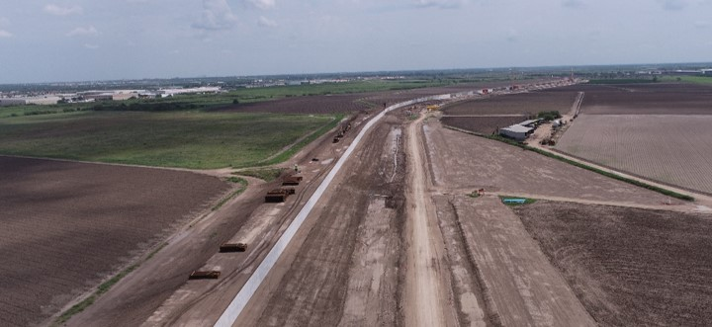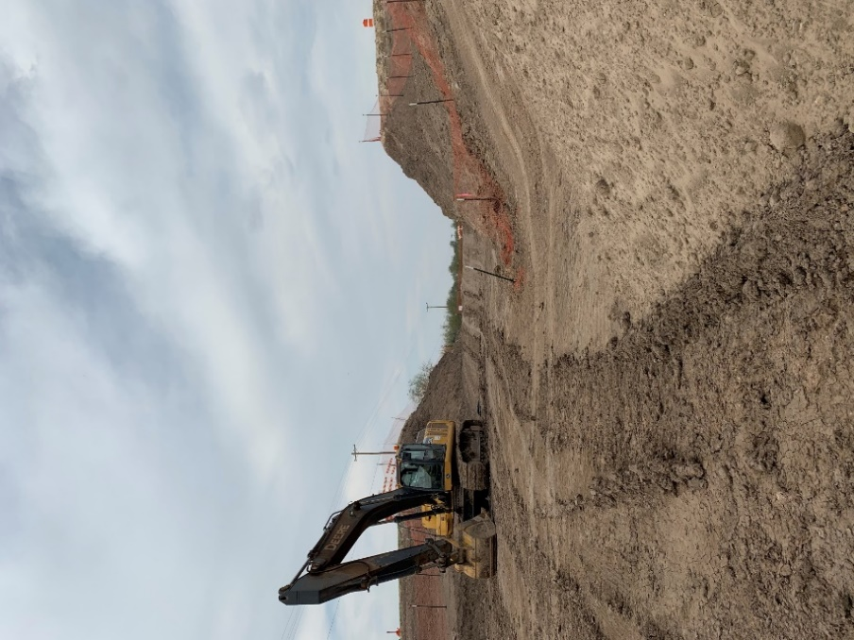
Incomplete floodwall with degraded levee is visible in the Rio Grande Valley community. (Official photo by U.S. Customs and Border Protection)

San Diego Erosion Protection/Control
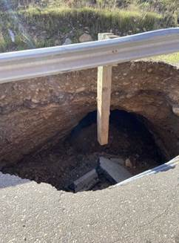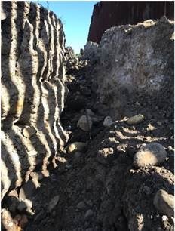
Erosion protections and corrective actions are needed along a 14-mile stretch in San Diego. (Official photo by U.S. Customs and Border Protection)

